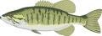
FishFerris 2025 – May 12, 2025

Contributions
Treasurer: Steve Bohren: Entry fee is $30 non-refundable ($15 for junior members) and due the first day member wants to fish
Website: Rick Manuszak: http://www.fishferris.com
Organizer: Tom Van Pernis

Guidelines
Species: Largemouth and Smallmouth Bass, 14" or larger (measured with mouth closed and tail compressed)
Tackle: Only artificial lures may be used. No "live bait" or "prepared bait" is permitted. Only one rod and reel combination may be used at one time. Trolling as a method of fishing is prohibited. All bass must be caught live and in a conventional sporting manner.
Scoring: Weight of up to five legal bass. Weigh-in is either at the launch (after season opener) or, alternately, anglers may provide a photo on scale or bump board (particularly for fish close to 14”) as evidence. May weigh 1 dead fish with a half-pound penalty.
Scorecard: Weight, length, and lure must be provided to count. Length will be used as a tie breaker for same weight.

Dates & Times
- Thursdays from May 15 through August 14. First cast at 6 pm sharp and a fish must be in the boat by end time to count.
- For the last two Thursdays in June and the first two Thursdays in July, fishing time will end at 9:30pm. All anglers back at launch within 15 minutes after end of fishing, half-pound penalty if late.
- If Thursday is rained out, an alternate date will be arranged.
- If anglers have a Thursday conflict and they may fish on Wednesday of the same week with approval of the organizer (preferable to have at least two boats). Days other than Wednesday may also be approved by the organizer, if needed. Must provide photo of fish and all other scoring information to organizer for entry onto website.

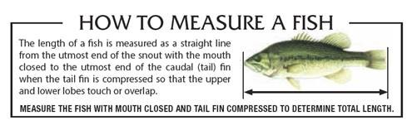
Fishing Locations See Web Site Schedule
May 15 Tri-Lakes July 03 Roger’s Pond
May 22 Muskegon River July 10 Clear Lake
May 29 Croton Pond July 17 Martiny Chain
June 5 Chippewa Lake July 24 Tri-Lakes
June 12 Jehnsen Lake July 31 Jehnsen Lake
June 19 Clear Lake Aug 7 Chippewa Lake
June 26 Townline Lake Aug 14 Muskegon River

Awards - All prize winnings will be paid out at the end of year get together (estimates based on 15 anglers)
